Dokumentasi HCI Final Project
- Kesya Amanda Wijaya – 2440021426
- Melvin Mario – 2440013456
- Rachel Onyx Sukianto – 2440011841

- Source of assets
- Index.html
- Home banner
  - The Ultimate Guide to Korean BBQ at Home · i am a food blog
  - (116) Pinterest
  - Korea's Famous and Classic Mixed Rice with Meat and Veggies (Bibimbap) (asianfoodnetwork.com)
- Content
  - 181114130138-korean-food-2620014201204004k-jeonju-bibimbap.jpg (1600×900) (cnn.com)
  - Everyday Bibimbap | Chu On This
  - Dakgangjeong (Sweet Crispy Korean Fried Chicken) - Korean Bapsang
  - Bingsoo - Paris Morning Bakery
  - » Hyunsung Korean restaurant by Jangmoksoo, Seoul – Korea (retaildesignblog.net)
- Location.html
- » Hyunsung Korean restaurant by Jangmoksoo, Seoul – Korea (retaildesignblog.net)
- Google Maps
- Menu.html
- https://chosungalbee.com/wp-content/uploads/2016/08/CSGB-Chadol-baegi.jpg
- Menu – SamWonHouse
- https://www.foodrepublic.com/recipes/how-to-make-yukhoe-korean-steak-tartare/
- Best Dakgangjeong Fried Chicken Recipe! (Soy Garlic & Spicy Yangnyeom) – FutureDish
- Dakgangjeong - Soy Garlic Fried Chicken - My Korean Kitchen
- CHIR CHIR INDONESIA – Korean Fusion Chicken Factory, PIK, Jakarta | ANAKJAJAN.COM
- Bingsoo - Paris Morning Bakery
- https://www.wine-searcher.com/images/labels/40/24/11034024.jpg
- Kuwaiti Cinnamon-Orange Iced Tea Recipe | Aarti Sequeira | Food Network
- https://www.static-src.com/wcsstore/Indraprastha/images/catalog/full/MTA-2837090/jinro-chamisul_jinro-chamisul-soju-korea-original-minuman-alkohol--360-ml-_full04.jpg
- https://www.static-src.com/wcsstore/Indraprastha/images/catalog/full//95/MTA-2168456/fanta_fanta-strawberry-can--330-ml-_full03.jpg
- Aboutus.html
  - The Ultimate Guide to Korean BBQ at Home · i am a food blog
  - Fontawesome (icons)
  - » Hyunsung Korean restaurant by Jangmoksoo, Seoul – Korea (retaildesignblog.net)
- Contactus.html
All by html, css, js.
- Footer
  - Fontawesome (icons)
- Problems
Pada slider, jquery tidak bersifat responsive.
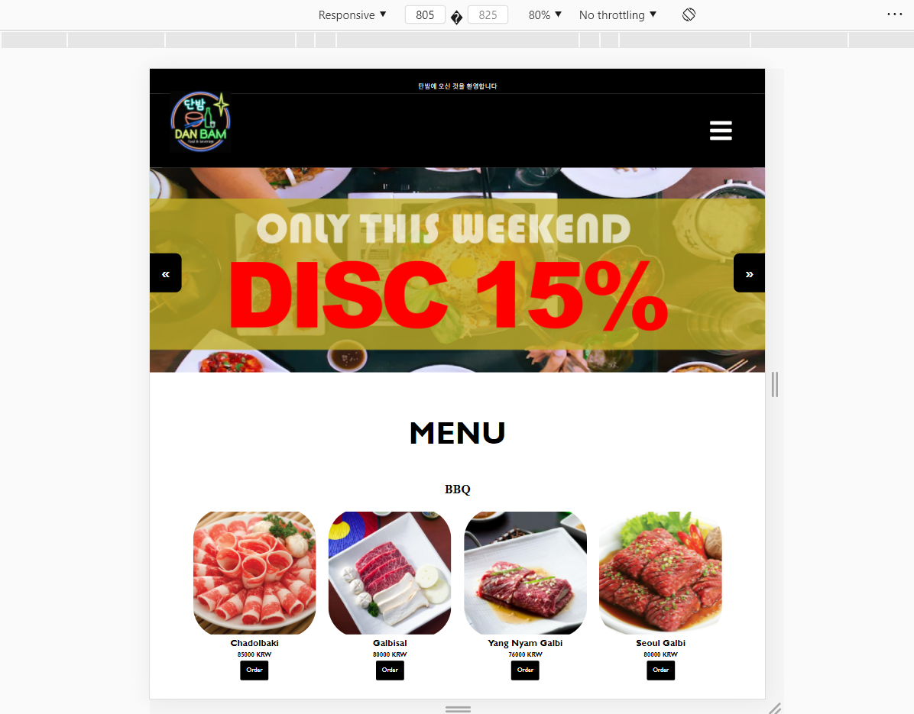
Figure 1 - Width 805 (responsive), pertama kali load
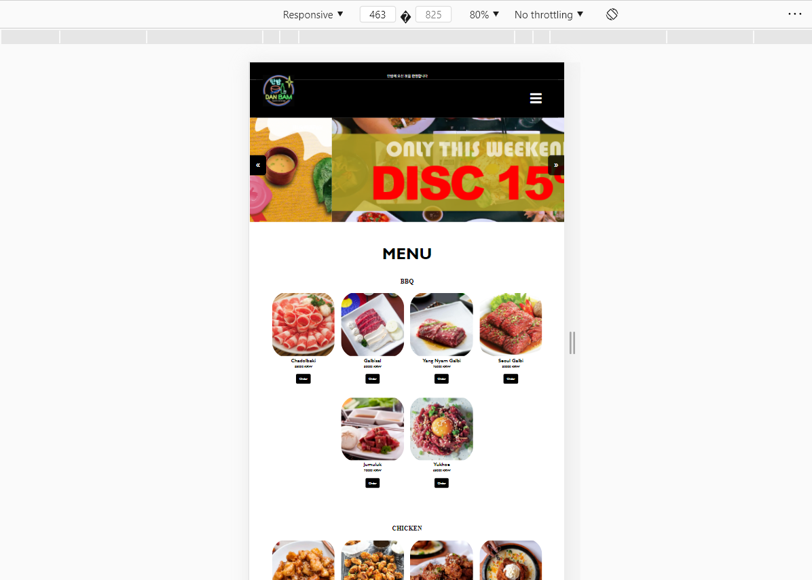
Figure 2 - Width 463 (responsive), jquery tidak adapt untuk width slidernya
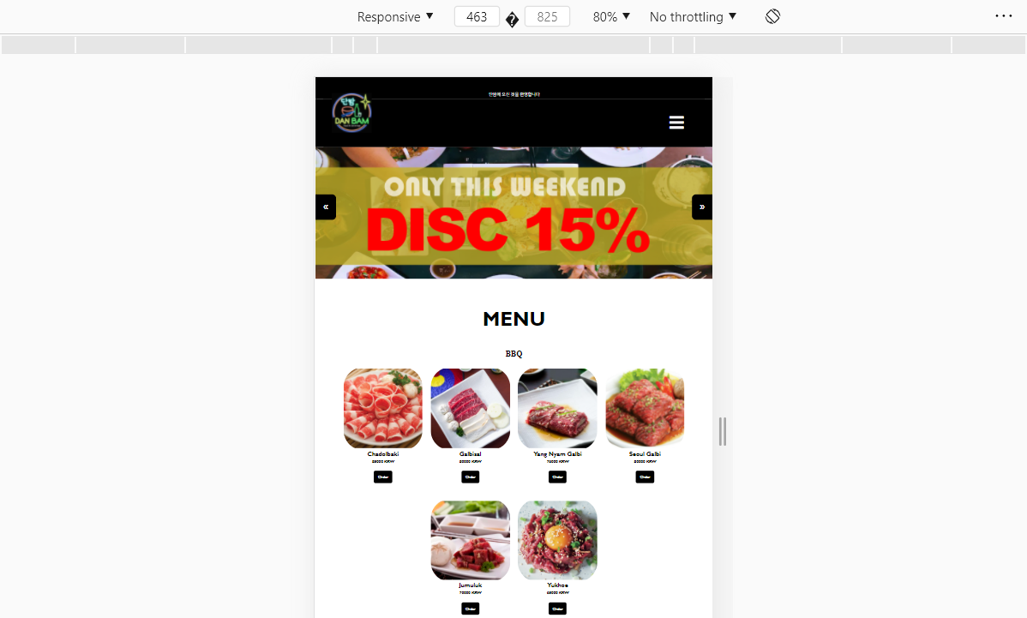
Figure 3 - Width 463 (responsive) setelah direfresh, width slider normal
Dikarenakan pada code, kami mendeclare variable:

let slideWidth = $(".slide").width();

sehingga saat document ready, width pertama sudah terinitialize dan tidak terganti saat kita mengganti width lagi. Solusinya harus direfresh, jika tidak, harus menggunakan library yaitu https://woocommerce.com/flexslider/ namun tidak diperbolehkan subco.

